**Topic:**

1. Strengthening communities through a human-centered design approach to open data
2. **How human-centered design can galvanize public engagement**
3. Making a case for human-centered design approach to open data to accelerate civic engagement

**Audience: open data portal makers, city governments, residents**

**Tags: Open Data, Transparency, Human Centered Design, Civic Engagement, Public Participation, Community Use of Open Data**

**Excerpt:**



“*We the People”: The first three words of the U.S. Constitution (Source: U.S. Constitution)*

Imagine that a heavy rain caused a pothole outside your house. You make a complaint to 311 but it takes them ten days to fix it. You’re disappointed by their lack of responsiveness and want to see if the resolution time of pothole complaints in other neighborhoods have taken just as much time or less. You go to the city’s open data portal to find that. To your dismay, it takes you 15 clicks to get to the desired data, and once you do get there, you’re overwhelmed by the volume of numbers so much so that you don’t know how to interpret it.

While [more than 100 American cities](http://us-city.census.okfn.org/) have released data on topics like budgets, crime, transportation, and properties, open data solutions aren’t always designed around the needs of the residents. When the residents find it difficult to use open data, it makes it harder for them to access useful data and to hold their governments accountable. At Sunlight, we think that a [human-centered design](http://www.designkit.org/human-centered-design) approach to open data is a great way to engage more closely with communities and drive social change.

**What is human-centered design?**

Human-centered design is the process of generating ideas from users and learning about their needs, identifying opportunities and prototyping possible solutions, and finally implementing the solution. It is an empathetic approach to solve problems where the needs of end users guide the entire process of solution. In specific, improving user interface (UI) design, tailoring data to specific communities and working hands-on-hands with residents by providing them with data-literacy tools are some of the ways in which open data can embrace human-centered design.

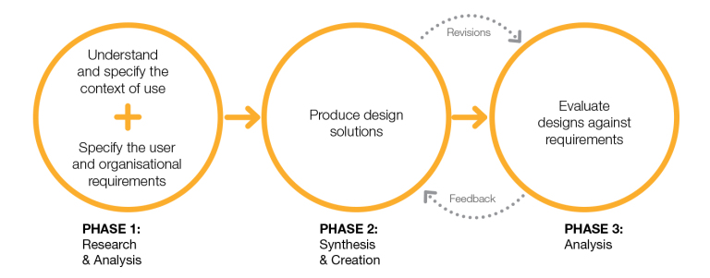

*Human-centered Design Model ISO 13407 (from Visocky O’Grady, 2008)*

**How can a better user interface design inspire public action?**

Human-centered design focuses on the all the touchpoints of the UI design. For example, a city government that launches a new open data portal shouldn’t only consider the volume of datasets it wants to make public. To provide a seamless user experience, it should also ensure there are interactive data visualizations for users to explore, easy-to-find “download” buttons, and an easy-to-navigate portal that takes as few clicks as possible to find the right dataset.

An organization that focuses on UI design is the Western Pennsylvania Regional Data Center (WPRDC), which maintains the open data portal for Allegheny County, the City of Pittsburgh, and surrounding areas. In 2016, it collected feedback from different groups of people including the city government, public authorities and community development organizations at its first [Property Data User Group Meeting](http://www.wprdc.org/news/property-data-user-group-meeting-recap/). The Center then developed an interactive map of [Allegheny County Crash Data](https://data.wprdc.org/dataset/allegheny-county-crash-data), which made it easier for users such as police officers to know where interventions were required. Keeping users at the heart of the solution has made it easier for people to access data in Pittsburgh and has [galvanized public engagement](http://pittnews.com/article/64296/news/open-data-connects-community/).

*Car crashes in Allegheny County, 2016 (source: wprdc.com)*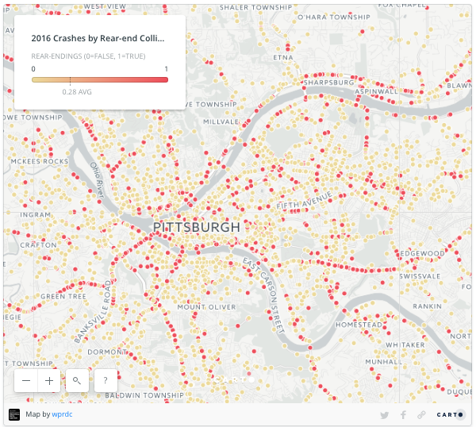

**Human centered design satisfies personalized needs of different communities**

Another trend in human-centered design for open data that has come about recently is the development of applications tailored to the needs of specific user groups. Identifying how interests of different users can be targeted can influence the usability of open data and help users make better decisions.

For example, the Mayor’s Office of Data Analytics (MODA) in New York recently developed the [NYC Business Atlas](https://maps.nyc.gov/businessatlas/), a mapping tool that allows entrepreneurs to study business and social conditions of different neighborhoods, by partnering with the Department of Small Business Services. This data was already available in the New York’s open data portal but did not offer the sophistication, specificity and context that would be useful to New York’s entrepreneurs. By developing an issue-focused tool in collaboration with small-business owners, MODA helped the business owners get a clear picture of the health of a [neighborhood before setting up their shops](https://www.inc.com/jill-krasny/nyc-business-atlas-helps-small-businesses.html) there.

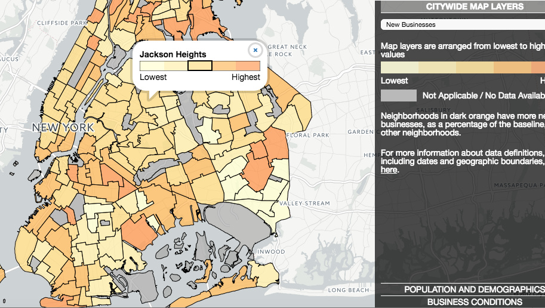

*NYC Business Atlas showing percentage change in number of new businesses from 2011 to 2013 (source: maps.nyc.gov)*

There are now a many who recognize the importance of having residents meaningfully engage with data.

“I am thrilled that the City of New York has released over 1,600 municipal datasets to the public. The fundamental goal is not only to make City data available, but also truly accessible, to the public.” said Helen Rosenthal, a New York City Council member, when the city [relaunched](http://www1.nyc.gov/office-of-the-mayor/news/137-17/de-blasio-administration-new-open-data-homepage-new-york-city-celebrates-5-years-open) its open data portal in March.

**Data literacy for public participation is critical to human-centered design**

Without providing literacy on how to access and use open data, it is difficult for residents to give feedback so that governments can continuously prototype open data solutions. Getting the residents knowledgeable on how to use open data tools is another essential component of a human-centered design, one that is also central to the democratic process.

To this end, the City of New York, in an effort to mark the completion of five years of the city’s [Open Data Law](https://www1.nyc.gov/site/doitt/initiatives/open-data-law.page), inaugurated “Open Data Week” to teach New Yorkers data-analysis skills to help them better understand [how](https://www.open-data.nyc/) their city works. Many city governments, including the City of Baltimore and City of Pittsburgh, host the annual “Data Day” with the goal to [enlighten public](http://bniajfi.org/baltimore_data_day) through workshops on how to access open data and why it can be actionable for communities.

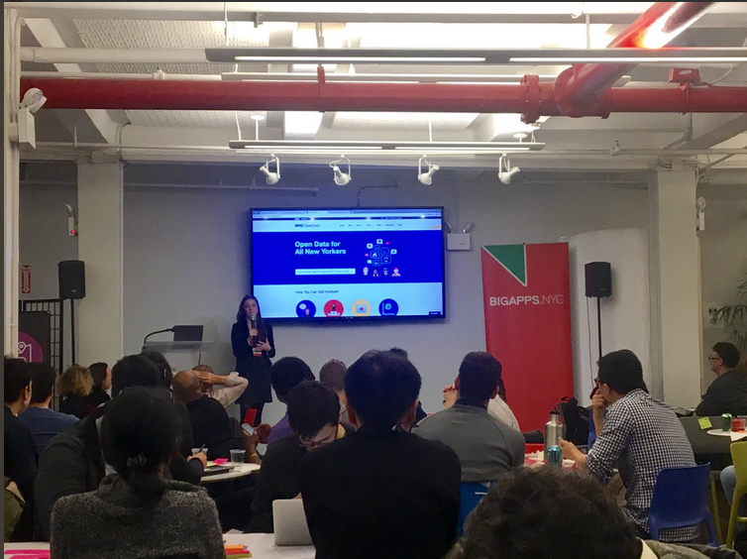

*Adrienne Schmoeker from NYC Analytics shares what can be done with NYC’s open data to the public. March, 2017 (source: @Genevieve Gaudet on Twitter)*

The decision to put residents at the forefront of open data movement, capture their needs in the open data solutions, and enable them to be the agents of democratic process are some of the benefits of a human-centered design approach to open data. By designing open data tools around the needs of residents, city governments build trust with their citizens and spark positive civic action for a greater good.